Zainab Zikar
Poisson EQUATION EVALUATED WITH GAUSS-SEIDEL AND SUCCESSIVE-OVER-RELAXATION

Abstract:
Poisson Equation can be used to solve problems regarding heat flow, electrostatics, gravity and other situations. To make the solution well defined four boundary conditions must be specified at the four corners. In the assigned question there were two Dirichlet boundary conditions and two Neumann conditions and the function U(x,y) was bounded over 0<x<2$π$, 0<y<2$π$. A mesh of points was formed and the accuracy of the approximation increased with the quality of the mesh. In a 2D grid each point is connected to four other points located along the cardinal direction. As a rule of thumb, the solution will converge if the U matrix is diagonally dominant, i.e. the numerically largest values occur on the diagonal and the code provided checks for diagonal dominance. For this Project the Gauss Seidel and Successive over relaxation methods were used to obtain the solution. The Gauss Seidel method is an iterative method that references an updated value um+1,j to solve for the next values. The SOR method is a refinement to the Gauss Seidel algorithm and converges faster. Data provided in the report will prove that SOR does indeed converge faster and requires less number of iterations. After computing the solution using the two methods the Method of Manufactured Solutions was applied to verify the accuracy of both the Gauss-Seidel and SOR approximations. The main purpose of this report is to learn to write a code to solve the Poisson equation using two iterative methods of solution, employ checkpoints and use data visualization to compare the results.

Mathematical statement of the problem

$$\frac{∂^{2}U}{∂x^{2}}+\frac{∂^{2}U}{∂y^{2}}=-F\left(x,y\right) (1)$$

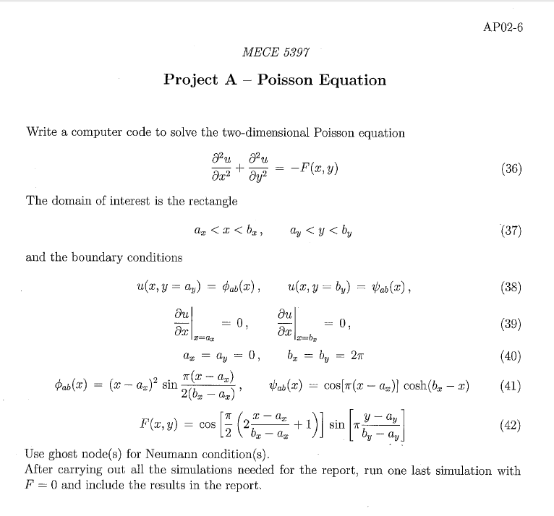

Discretized version of the equations

$\frac{U_{i-1,j}+U_{i+1,j}-2U_{i,j} }{∆x^{2}}+\frac{U_{i-1,j}+U_{i+1,j}-2U_{i,j} }{∆y^{2}}=F_{i,j}$ (2)
The scanned documents below show extended working

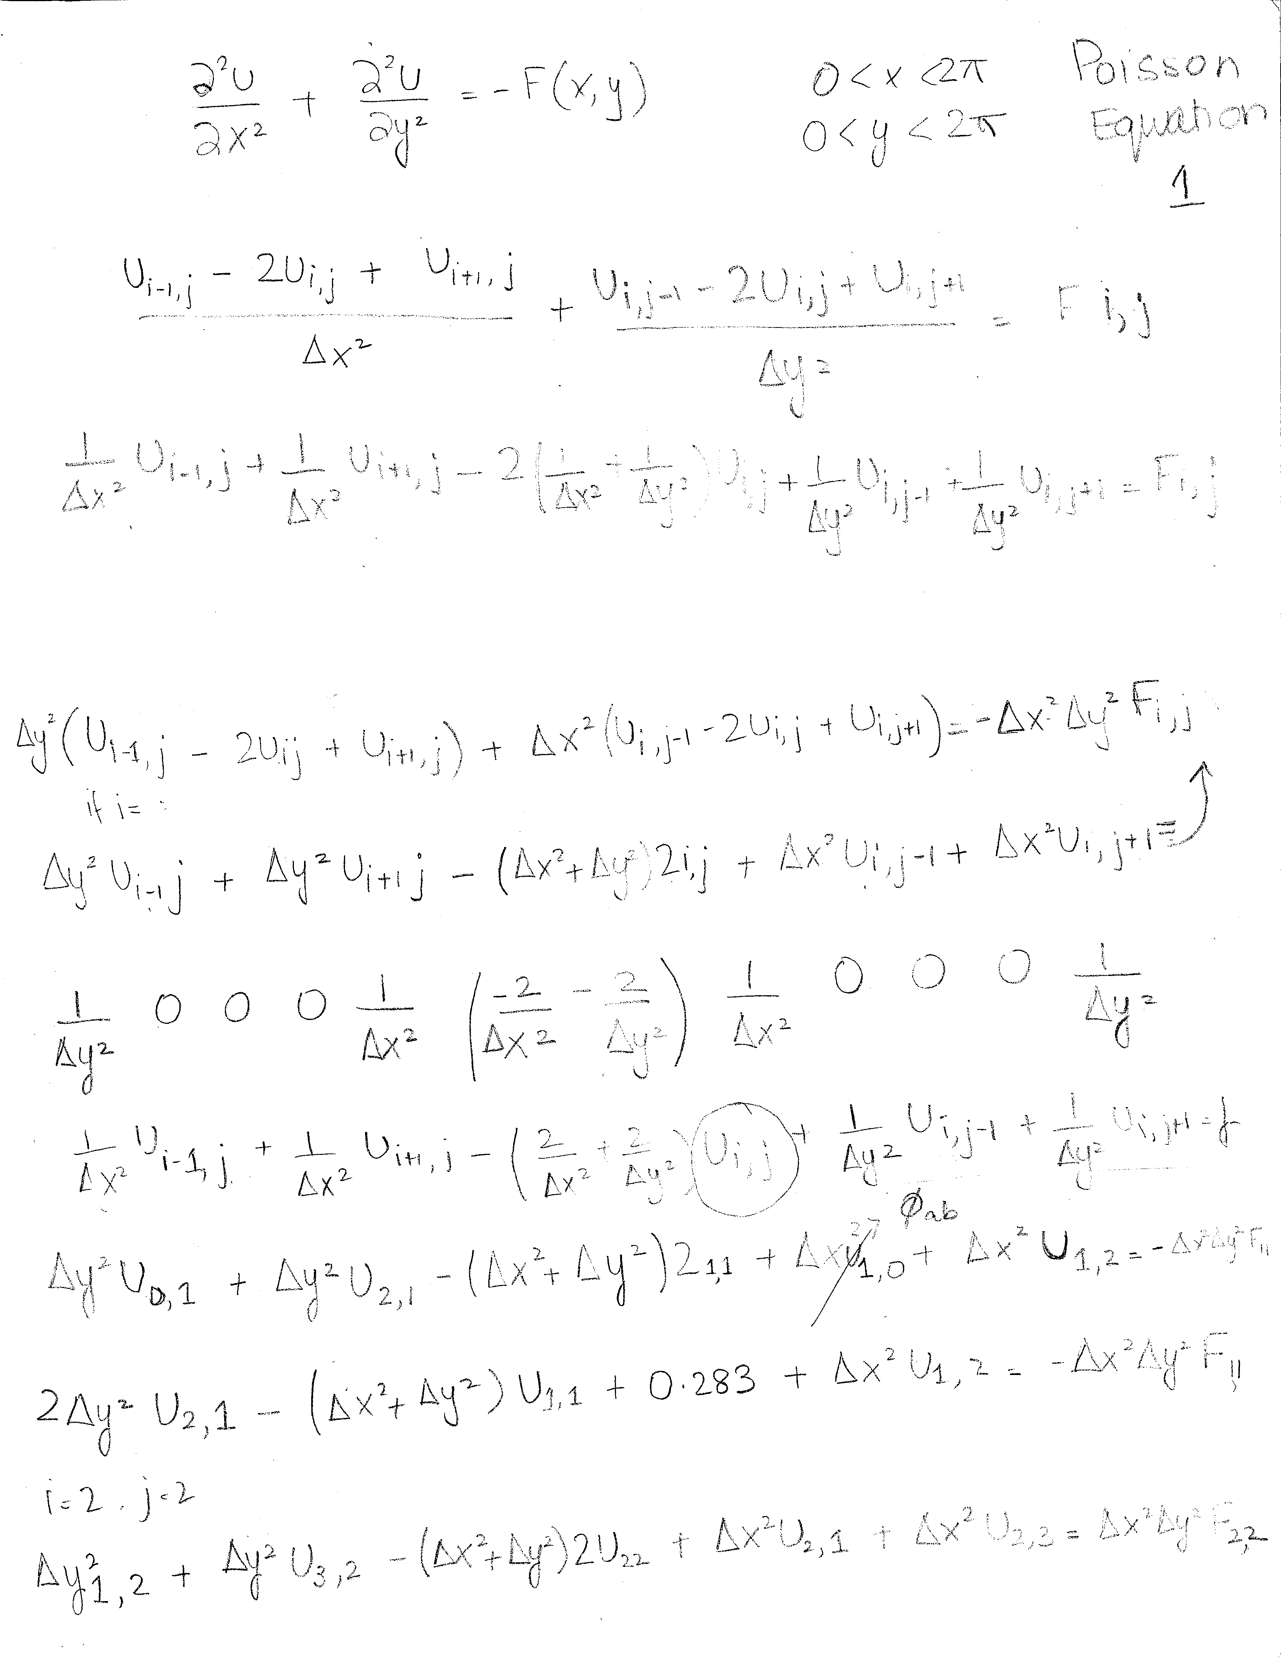

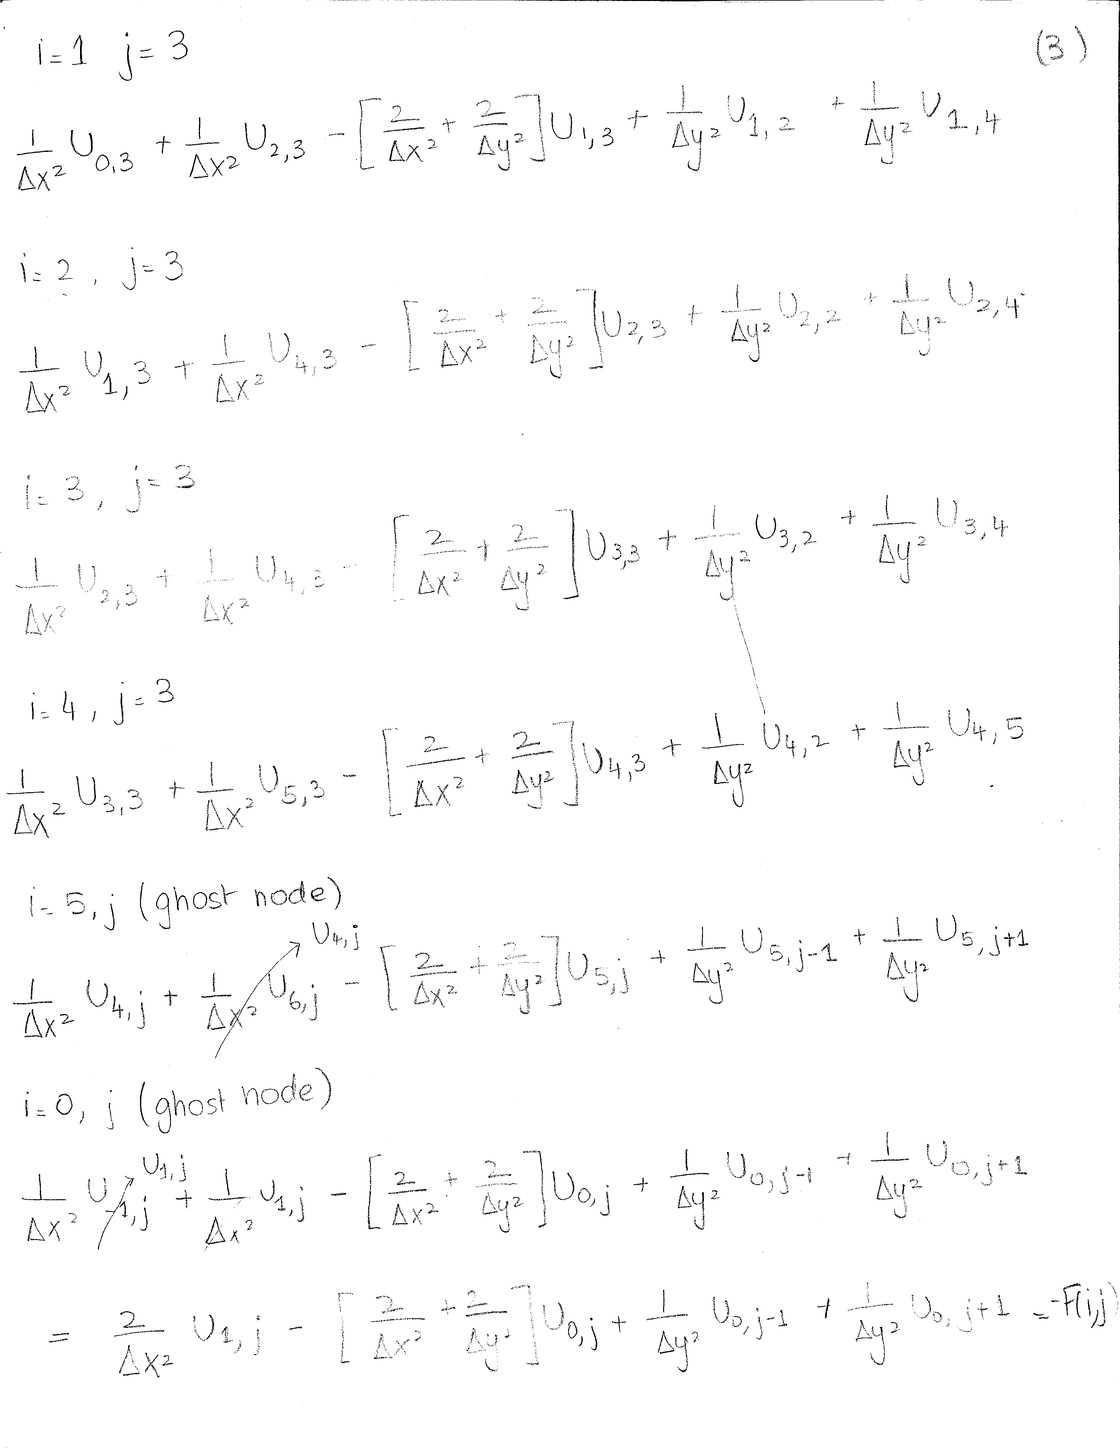

Description of the numerical method
Two iterative solvers were used to solve the Poisson equation on Cartesian grids in two dimensions. Te first method employed was the called Gauss-Seidel method which uses an already computed value to compute the next value as shown in equation 3. Using the initial guess (in our case U=zeros(M,N)) the discretized equations are evaluated solving for U(i,j), the value at the point being examined. When the first value is computed the values in the initial guess matrix are substituted with the new U values( $U_{i,j})$and used for each successive calculation. This process continues until the maximum error of the full system iteration reaches a set point error value that is predetermined for adequacy and system convergence.

${U^{n+1}}_{i,j}=\frac{{F_{i,j}\left(∆x^{2}∆y^{2}\right)-(U^{n+1}}_{i-1,j}+{U^{n}}_{i+1,j})∆y^{2}{{ - (U}^{n+1}}_{i,j-1}+{U^{n}}_{i,j+1}) ∆x^{2} }{-2(∆x^{2}+∆y^{2})}$ (3)
The SOR method on the other hand converged much faster than the Gauss-Seidel method did, The SOR method is the same equation as the Gauss-Seidel equation, the only difference being that the SOR method has a relaxation weighting factor called ω. If you set ω = 1, then the result you get is the Gauss-Seidel equation exactly. For the solution to converge, ω must be between 1 < ω < 2.

${U^{n+1}}_{i,j}=ω \left(\frac{{F_{i,j}\left(∆x^{2}∆y^{2}\right)-(U^{n+1}}_{i-1,j}+{U^{n}}_{i+1,j})∆y^{2}{{ - (U}^{n+1}}_{i,j-1}+{U^{n}}_{i,j+1}) ∆x^{2} }{-2\left(∆x^{2}+∆y^{2}\right)}\right)+\left(1-ω\right)U_{i,j}$ (4)

Technical specifications of computer used:

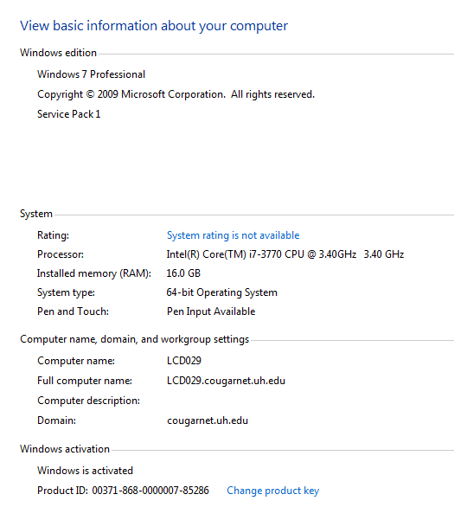

Results
Using these images we can see that the Neumann Boundary condition was met since the slope at the far left and right boundary of the plot is equal to zero. Figue 1 is the plot of 23 X internal nodes and 23 Y internal codes. Figure 2 shows a 123 by 123 mesh size which gives a better quality graph.

25x25
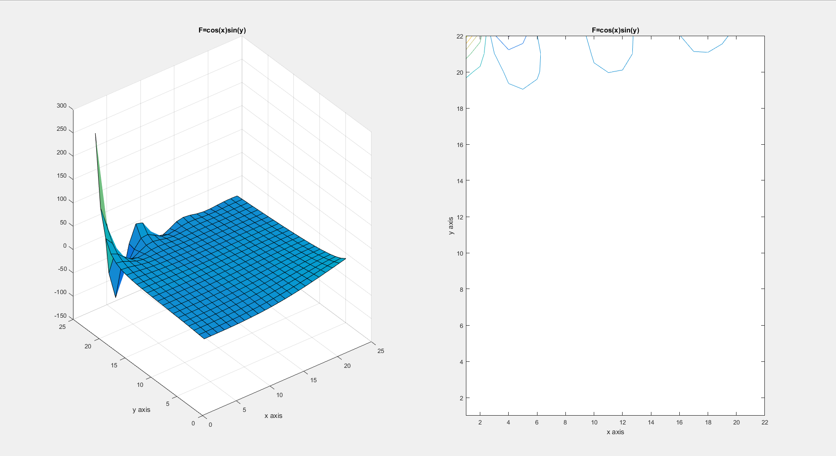
Figure 1

125x125
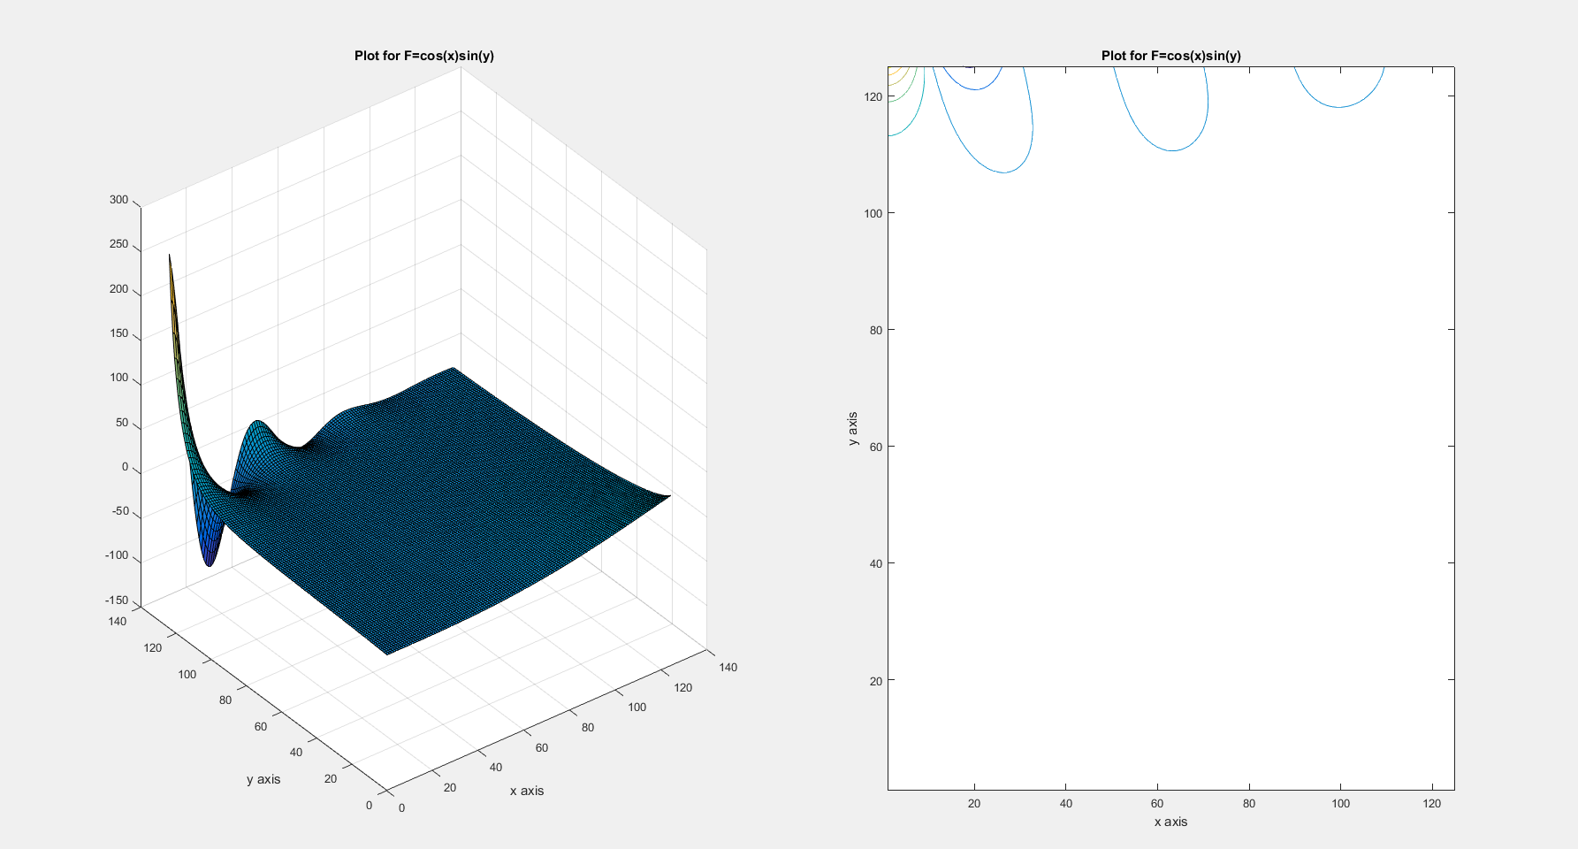
Figure 2
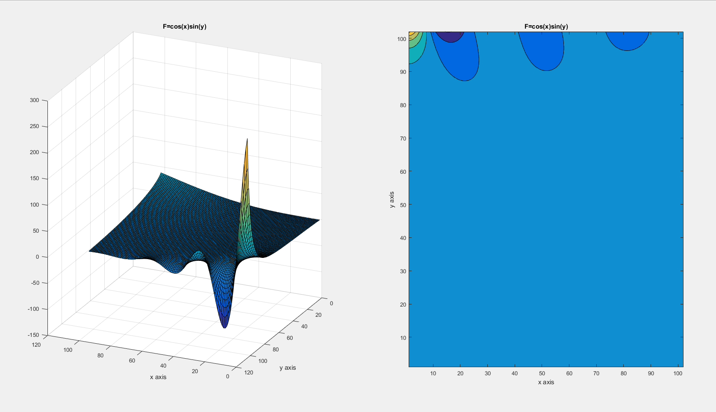
Figure 3

Graphs With F=0
25x25
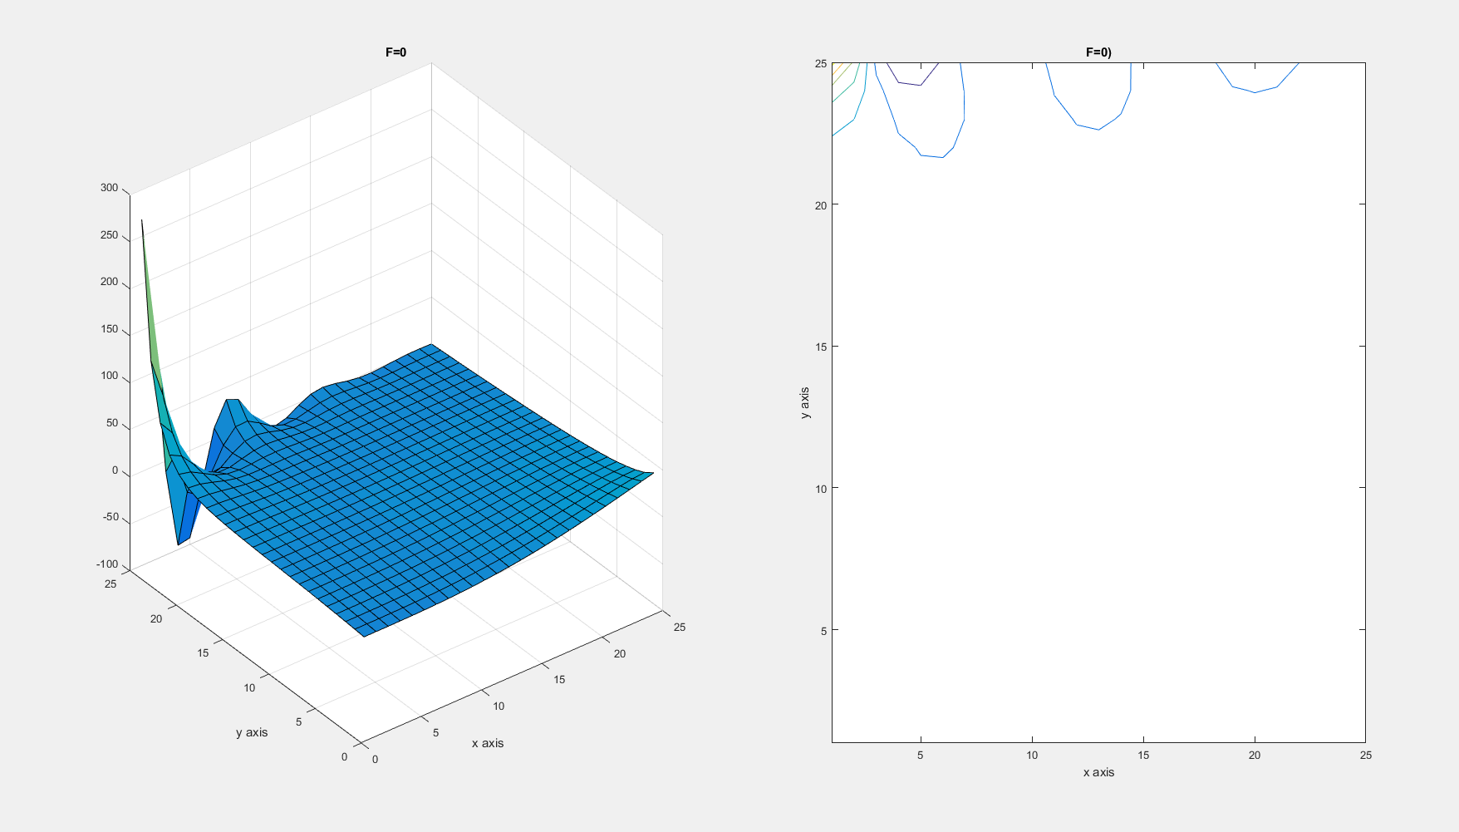
Figure 4
125x125
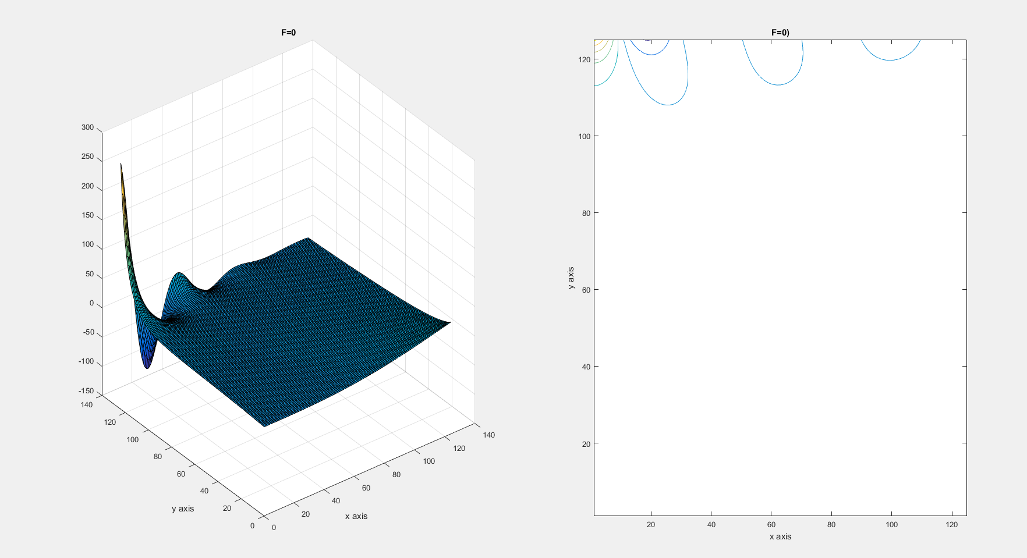
Figure 5

Verification
Method of manufacturing solutions was used to verify the code. The function used to verify the code was cos(xy). Figure 6 shows the working of the method of manufacturing solutions. Figures 7 and 8 show that the graphs looked very similar to the graphs of the actual code.
Manufactured SOR
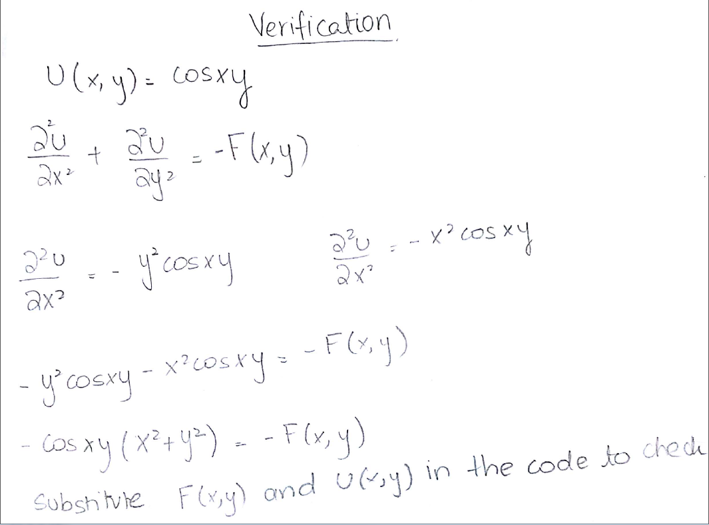
Figure 6

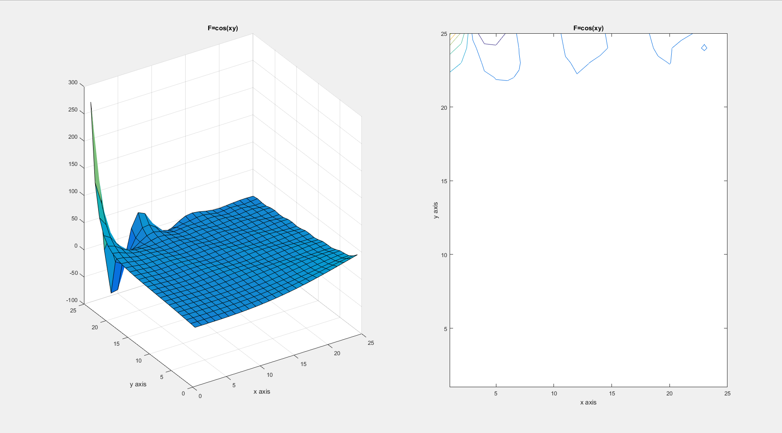
Figure 7:25x25, Manufactured solution

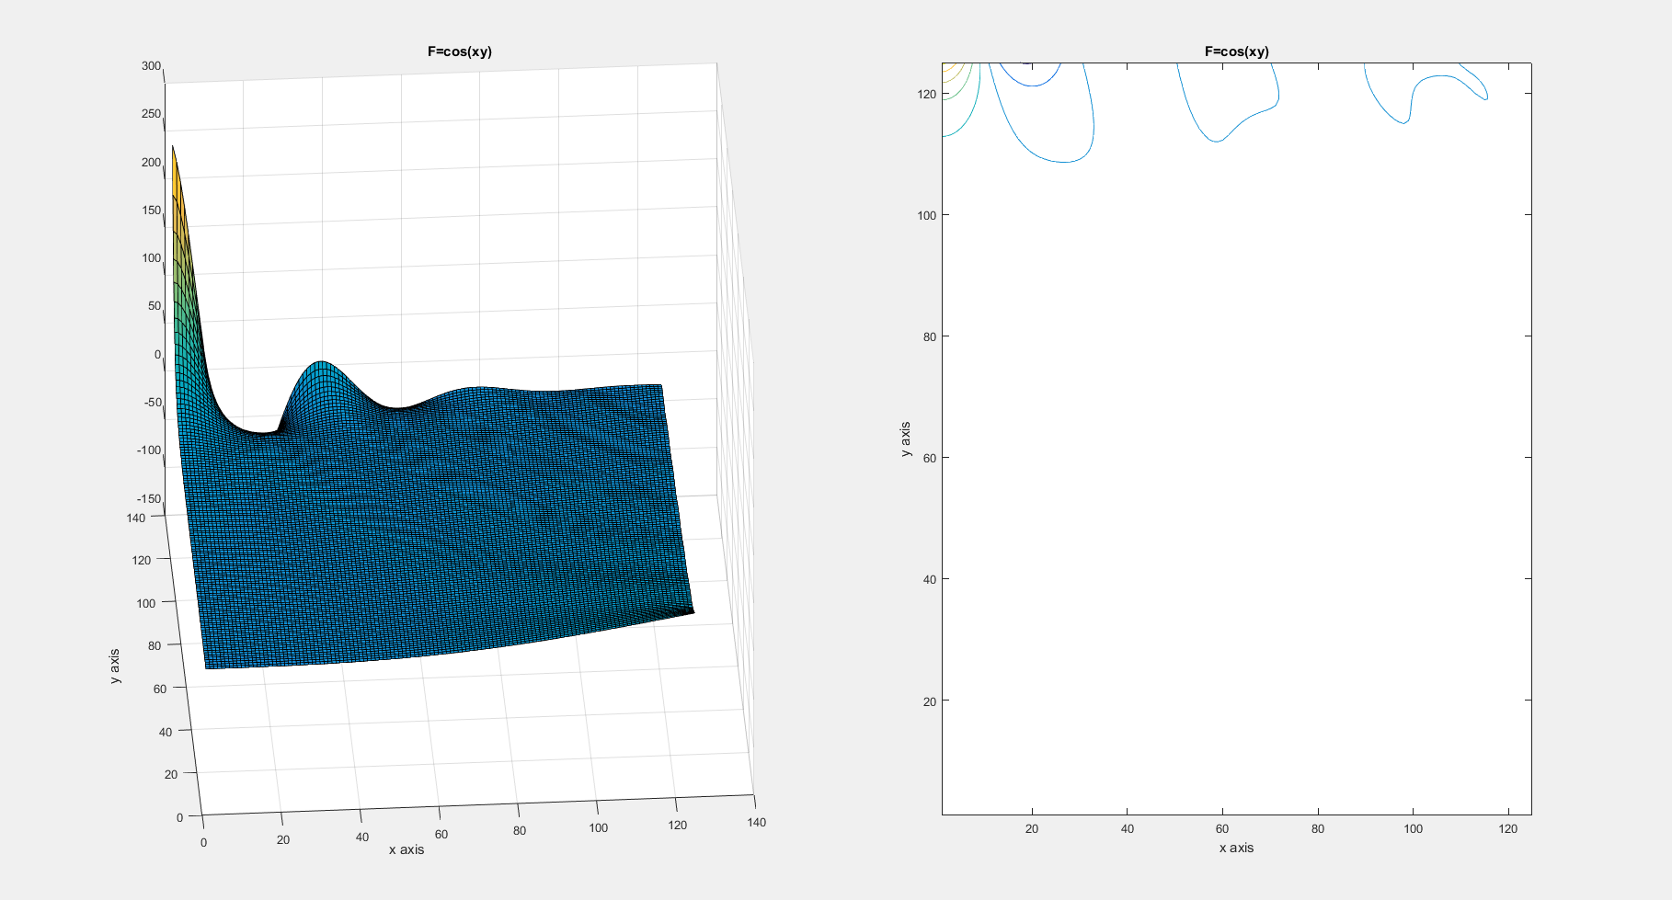
Figure 8: 125x125, Manufactured solution

Grid Independence Study
A grid independence study was done by taking the mean of the mean of the solution matrix squared element by element, and then comparing the values for various grid sizes. The smallest grid size selected was 10x10 and was increased to 200x200 when the Average U^2 values started converging
Table 1
SOR (λ=1.6)
N value | Average of U^2
10 | 693.7868
20 | 345.8155
40 | 229.191
80 | 185.1633
120 | 172.6469
160 | 166.7872
200 | 163.3967
250 | 162.7511

Figure 9
Table 2 shows the number of while loop iterations and the total time taken for the system to converge for the Gauss-Seidel Method, SOR method, with different functions. The last case shows results obtained by using the method of manufacturing solutions. The results prove that SOR converges faster than Gauss-Seidel and that it’s a better iterative method to solve the Poisson Equation.
Table 2
 |  |  | Gauss Seidel |  | SOR (λ=1.5) |  | Gauss Seidel |  | SOR (λ=1.5) |  | Gauss Seidel |  | SOR (λ=1.5)
 |  | M,N | 25x25 |  | 25x25 |  | 75x75 |  | 75x75 |  | 125x125 |  | 125x125
F=Function |  | Number of Iterations | 2415 |  | 903 |  | 22046 |  | 7930 |  | 75645 |  | 26717
 |  | Amount of time | 0.181 |  | 0.1 |  | 13.6279 |  | 5.8203 |  | 126.49 |  | 53.4777
 |  | M,N | 25x25 |  | 25x25 |  | 75x75 |  | 75x75 |  | 125x125 |  | 125x125
F=0 |  | Number of Iterations | 2431 |  | 908 |  | 23043 |  | 8270 |  | 71145 |  | 23263
 |  | Amount of time | 0.2064 |  | 0.1336 |  | 14.239 |  | 6.1659 |  | 122.3024 |  | 46.2583
 |  | M,N | 25x25 |  | 25x25 |  | 75x75 |  | 75x75 |  | 125x125 |  | 125x125
F=cosxy (Manufactured Solution) |  | Number of Iterations | 2523 |  | 1043 |  | 24328 |  | 8723 |  | 64204 |  | 22853
 |  | Amount of time | 0.2223 |  | 0.1309 |  | 14.4684 |  | 6.3945 |  | 103.6025 |  | 44.6946

